SIMATS ENGINEERING (SAVEETHA SCHOOL OF ENGINEERING)
Department of Computer Science and Engineering
CO1 ASSESSMENT TOOL 1 – Case Study Analysis
Course Code: | CSA1001 | Course Title: | Software Engineering
CO Assessed: | CO1 | Assessment: | Assessment Tool 1 – Case Study Analysis
Weightage: | 20% | Total Marks: | 25
CO1 Statement: | Apply advanced methodologies and agile project management techniques to manage software projects effectively
Student Name: | Fermy Selvanathan G | Reg. No.:
Date: | 01-10-2026 | Duration: | 60 minutes

Code of Conduct
I Fermy Selvanathan/ certify that this submission is my original work and that I have adhered to the guidelines specified for this assessment. I understand that any violation of academic integrity rules will result in disciplinary action.
Signature of the Student: _________________________

Annexure A – Case Study Analysis
Instructions to Students:
Each student will be allotted one problem statement. Analyze the assigned problem systematically by following the steps given below. Your report should demonstrate your understanding of software engineering concepts and your ability to design an appropriate software solution.
Based on your allotted problem statement, prepare a report by answering the following questions:
Development of an Online Verification System for Weighing and Measuring Instruments
1. Understand the Problem Statement
1.1 Introduction
Weighing and measuring instruments are used in shops, industries, laboratories, markets and other business areas. Examples include weighing machines, measuring scales and fuel measuring devices. These instruments must give correct measurements because wrong measurements can affect both customers and businesses.
The verification process can involve manual work. Instrument details, owner details, verification dates and results may be recorded on paper or in separate records. When the number of instruments increases, this process can become slow and difficult to manage.
The proposed Online Verification System provides one online platform for submitting instrument details, applying for verification, checking application status and storing verification records. It also helps officers manage applications in one place.
1.2 Problem Description
The main problem is that a manual verification process can take more time and make record management difficult. Users may need to visit an office, submit documents and wait for updates. Officers may also spend time searching records and entering the same information manually.
- Paper records are difficult to search and maintain.
- Users may not know the current application status.
- Processing applications can take more time.
- Manual data entry can cause mistakes.
- Old verification records can be difficult to find.
- Managing many instruments becomes harder as records increase.
1.3 Objectives
- Provide an online platform for instrument verification.
- Reduce paperwork and manual work.
- Allow users to submit instrument details and applications online.
- Allow officers to review applications and record results.
- Store verification records digitally.
- Allow users to track application status.
- Make previous records easier to search.
- Reduce errors and improve the overall verification process.
1.4 Scope
The system covers user registration, instrument registration, online applications, document upload, application tracking, officer verification, verification results, digital records, notifications, searching previous records and administration. It is intended for instrument owners, verification officers and administrators.
The system does not completely replace physical testing. When an instrument must be physically inspected, the online system supports the application, scheduling, records and result of that inspection.
2. Identify Key Stakeholders and Challenges
2.1 Main Stakeholders
Instrument Owners – register instruments, submit applications, upload documents and check status.
Verification Officers – check applications, inspect instruments when required and record results.
System Administrator – manages users, roles, settings and system access.
Department Officials – monitor applications, verification data and reports.
Development and Maintenance Team – develops, fixes and improves the system.
2.2 Instrument Owners
Instrument owners may be individuals or businesses using weighing or measuring instruments. They need a simple way to apply for verification and check the progress of their application.
Register and provide instrument details.
Submit applications and required documents.
Pay a fee if required.
Check application status.
Attend physical verification when required.
View or download verification details.
Their main challenges are office visits, waiting for updates, managing documents and the time needed for manual applications.
2.3 Verification Officers
Verification officers process applications and check instruments. They review documents, schedule or perform verification, record results and approve or reject applications.
Their main challenges are handling many applications, searching old records and avoiding mistakes during manual data entry. An officer dashboard can make these tasks easier.
2.4 Administrator and Officials
The administrator manages users, officer accounts, roles, settings and system security. Department officials mainly use records and reports to monitor the verification process. Both groups need accurate and up-to-date information.
2.5 Major Challenges
Manual work can take more time and may cause errors.
A large number of records can be difficult to manage.
Users may have difficulty tracking applications.
Personal and instrument information must be protected.
Users and officers need clear communication about application status.
Physical inspection may still be required for some instruments.
3. Analyze the Current Approach
3.1 Existing Process
A general current process is: the owner submits an application, instrument details and documents are collected, the application is assigned to an officer, the instrument is inspected or tested, the officer records the result, and the application is approved or rejected. The verification details are then stored and the owner receives the result.
When these activities depend mainly on paper records or separate records, it becomes harder to manage a large number of applications.
3.2 Strengths
- Officers can directly inspect the instrument when needed.
- The existing process is familiar to officers.
- Physical verification can still be carried out.
- Existing records can be maintained.
3.3 Limitations and Gaps
- Users may have to visit offices and submit documents physically.
- Paperwork takes space and is harder to maintain.
- Finding old records can take time.
- Users may not receive status information quickly.
- Manual data entry can result in incorrect information.
- Officials may find it difficult to monitor all applications together.
- The main gap is the lack of one simple system that connects users, officers and verification records.
4. Propose a Suitable Solution Using Software Engineering Principles
4.1 System Overview
The proposed system is a single online platform where instrument owners can register instruments and submit verification applications. Officers can review applications, check documents, record verification results and update application status. The system stores the information in a database.
Basic flow: User Registration → Instrument Registration → Application → Document Submission → Officer Review → Verification → Result → Digital Record.
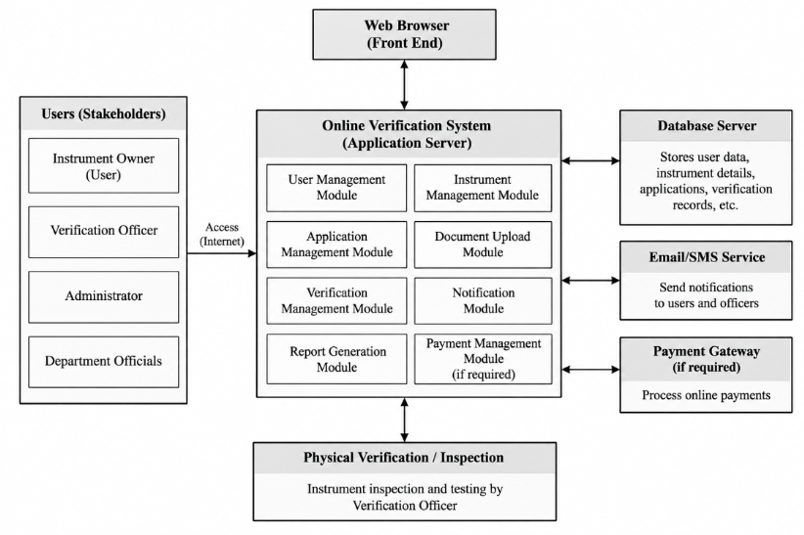

4.2 Major Modules
User Registration and Login
Users create accounts and log in securely. Different roles such as User, Verification Officer and Administrator can have different access rights.
Instrument Registration
Owners enter details such as instrument type, instrument number, manufacturer, model, capacity, location, owner details and previous verification information.
Verification Application
After registering an instrument, the owner submits a verification application with the required information and documents. The system provides an application number for tracking.
Document Upload
Users can upload required documents. Officers can view these documents while checking the application, reducing the need for physical copies.
Officer Dashboard
The dashboard shows new, pending, under-verification, approved, rejected and previous applications. This gives officers one place to manage their work.
Verification and Result
After checking the instrument, the officer records the verification date, instrument details, test result, status and remarks. The result is saved in the system.
Application Tracking
Users can check whether an application is submitted, under review, scheduled for verification, verified or approved. Remarks can be shown when action is needed.
Digital Record and Reports
After successful verification, the system can provide a digital verification record or certificate. Reports can show total, pending, approved and rejected applications, verified instruments and verification history.
4.3 Functional Requirements
- User registration and login.
- Instrument registration.
- Online application submission.
- Document upload.
- Application number generation.
- Officer application review.
- Application status updates.
- Verification result entry.
- Application tracking.
- Digital verification records.
- User and role management.
- Reports and status notifications.

4.4 Non-Functional Requirements
Security – only authorized users should access protected information.
Usability – screens should be simple and easy to understand.
Reliability – important records should be stored safely.
Performance – common actions should respond quickly.
Scalability – the system should support more users and instruments as it grows.
Maintainability – the system should be easy to update and fix.
Availability – the service should normally be available when users need it.
4.5 Software Engineering Principles
The system follows modularity by separating features such as login, instrument registration, applications and verification. Scalability allows more users and instruments to be added later. Maintainability is supported by organized code and separate modules. Reliability is improved through safe record storage and backups. Usability is supported by simple screens. Security is supported through login, user roles and access control.
5. Justify the Chosen Methodology/Framework
5.1 Selected Methodology – Agile
Agile is suitable because the system can be developed in small parts instead of waiting until the entire system is completed. Each part can be tested and reviewed before moving to the next part.
Sprint 1 – Login and user registration.
Sprint 2 – Instrument registration.
Sprint 3 – Application submission and documents.
Sprint 4 – Officer dashboard and application review.
Sprint 5 – Verification and results.
Sprint 6 – Reports and notifications.
5.2 Why Agile is Suitable
Changes can be added more easily when users give feedback. Each module can be tested after development. A basic working version can be available early. Problems can be found earlier. Developers, testers and users can communicate regularly.
Agile also supports continuous improvement after feedback. This is useful for a system where department requirements may change during development.
5.3 Maintenance
After release, the system needs regular maintenance. This includes fixing errors, updating security, improving performance, taking backups, adding features and supporting users. Since the system is divided into modules, changes can be made more easily.
6. Discuss Expected Outcomes and Limitations
6.1 Expected Benefits
- Faster applications because many steps can be completed online.
- Less paperwork because records and documents can be stored digitally.
- Easy application tracking for users.
- Better storage and searching of verification records.
- Fewer manual data-entry errors through forms and checks.
- Easy access to previous records for officers.
- Better monitoring through reports.
- Less dependence on repeated office visits.
6.2 Risks and Challenges
Internet problems may stop users from accessing the service.
Security risks must be handled carefully.
Some users and officers may need basic training.
Server or software problems may temporarily affect the service.
Physical inspection may still be needed for some instruments.
Incorrect information entered by users must be checked.
6.3 Limitations
The system depends on internet access.
Physical verification cannot always be replaced.
Users need basic knowledge of using an online system.
Regular maintenance is required.
Security must be monitored continuously.
Initial development requires time and resources.
6.4 Future Enhancements
- Mobile application for easier access.
- SMS notifications for application updates.
- Online payment where required.
- QR code on digital verification records.
- Automatic reminders before verification expiry.
- More detailed reports and charts.
- Connection with other department systems in the future.
Conclusion
The Online Verification System for Weighing and Measuring Instruments can make the verification process more organized and easier to manage. The current manual process can cause paperwork, delays, difficulty in searching records and difficulty in tracking applications.
The proposed system provides one platform for instrument owners, verification officers and administrators. Users can register instruments, submit applications, upload documents and track status. Officers can review applications, record verification results and maintain digital records. Administrators can manage users and reports.
Agile is suitable because the system can be developed in small parts, tested regularly and improved using user feedback. Principles such as modularity, scalability, maintainability, reliability, usability and security can help make the system useful and easier to maintain.
Rubrics for Calculation
Criteria | Excellent (5 Marks) | Good (3 Marks) | Satisfactory (2 Marks) | Needs Improvement (1 Mark)
Problem Understanding (30%) | Clearly explains the problem, objectives, and scope with complete understanding. | Explains the problem with minor omissions. | Basic understanding with limited explanation. | Poor understanding; objectives and scope are unclear or missing.
Stakeholder & Challenge Analysis (25%) | Identifies all stakeholders, their roles, and challenges with clear analysis. | Identifies most stakeholders and challenges with adequate analysis. | Identifies only a few stakeholders or challenges. | Stakeholders and system analysis are incomplete or inaccurate.
Current System Analysis (20%) | Thoroughly analyzes the existing system, strengths, weaknesses, and identifies all gaps. | Good analysis with most strengths and weaknesses identified. | Limited analysis with partial identification of issues. | Proposed solution is unclear or inappropriate; requirements are largely missing.
Proposed Software Solution & Software Engineering Principles (15%) | Proposes an innovative, feasible solution applying appropriate software engineering principles (modularity, scalability, maintainability, security, etc.). | Suitable solution with good application of software engineering principles. | Basic solution with limited application of software engineering principles. | Methodology is inappropriate, poorly justified, or not discussed.
Methodology/ Framework Justification (10%) | Selects the most suitable SDLC/model/framework and provides strong technical justification. | Suitable methodology selected with adequate justification. | Methodology selected but justification is weak. | Outcomes, limitations, or future enhancements are missing; report lacks organization and clarity.

Criteria | Mark
Problem Understanding (30%) | /5
Stakeholder & Challenge Analysis (25%) | /5
Current System Analysis (20%) | /5
Proposed Software Solution & Software Engineering Principles (15%) | /5
Methodology/ Framework Justification (10%) | /5
TOTAL | /25

